Garowe Consultations Meeting on Border Demarcation Meeting Minutes
Title: Inclusive Governance TWG Consultation Meeting
Venue: GOBSOOR CONFERENCE Hall in Garowe
Duration- 4th -5th January 2018
Implemented by: - PUNSAA (IG TWG)
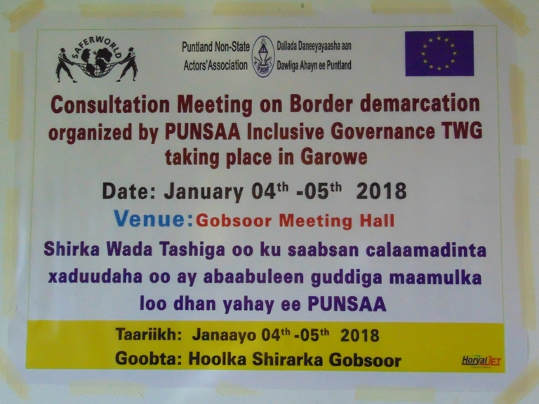

Background/Introduction
Two days consultation meeting was held at GOBSOOR Hotel, Garowe on 4th – 5th January,2018. The meeting was attended by 25 members from different regions of Puntland regions including Senior officer from Puntland Ministry of Interior (MoI), Different sectors of the Civil Society Organization and experts. After recitation of Quran verse, PUNSAA Executive Director explained the Objectives of this consultation meeting and welcome the participants. He also emphasized the importance of this consultation by stressing that the results of this consultation would help to the government, stakeholders and community which may provide better solutions to some of the important questions frequently rose relating to the border demarcation.

Objectives
At the end of the consultation meeting, it is expected to:
- get clear borders between districts and regions of Puntland before the election of 2019

Methodology
The discussion was an interactive and participatory.
The following methods have been utilized in the meeting:
- Brainstorming
- Group discussions
- Debate
- Ideas exchange and experience sharing
- Calling a resource person
- Inputs
- Note-taking

The Agendas of the meeting were to:
- Know the Puntland districts and regions borders situation
- Comprehend the existing problems and recommend solutions to address those problems
- Set the Possible solutions for Puntland Districts/Regions border disputes
- Recommend to establish an Independent Puntland level committee on regional and districts border disputes
- Share the participants for PUNSAA conducted research on Puntland border demarcation.
- Production of Statement on Puntland Border Demarcation from the participants.

Opening remarks
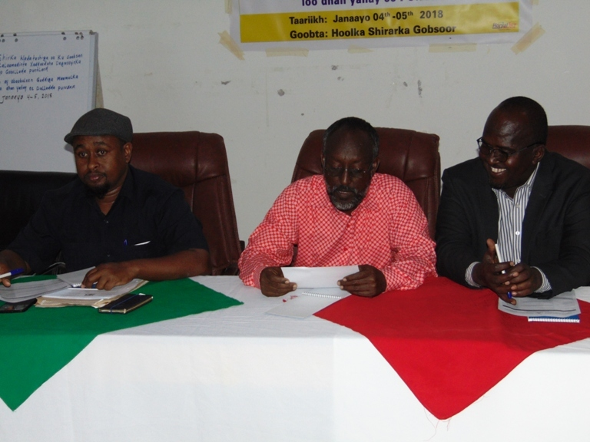Opening Ceremony by PUNSAA Chairman, Director General of Puntland Ministry of Interior and the Deputy Minister of Puntland Ministry of Interior

PUNSAA Chairman, Director General of Puntland Ministry of Interior and the Deputy Minister of Puntland Ministry of Interior were officially opened the meeting/discussion and an eagerly asked the participants to show an active participation through all sessions of the two days consultation meeting and present their views and concerns.
As planned, the discussion started on January 4, 2018 with 25 members of CSOs from different regions Regions of Puntland together with IG TWG members and Government Officers.
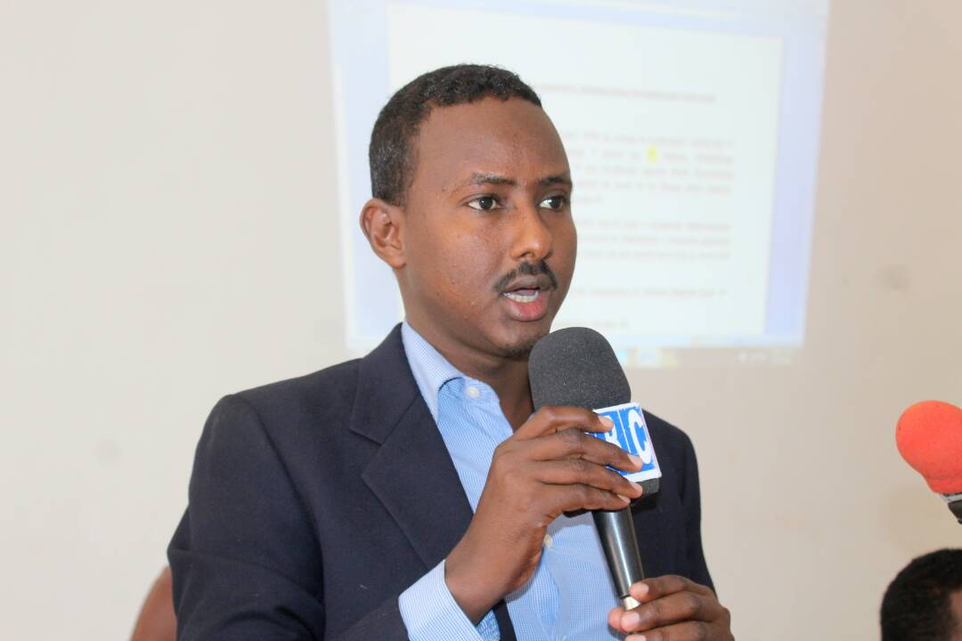
Executive Director sharing the participants for the objectives of the meeting

PUNSAA Executive Director during Opening session sharing with the participants the objectives of this consultation meeting

Day 1:
Topic 1: Questions asked to the Officers from Puntland Ministry of Interior
In this session the participants were asked the Officers from the Puntland Ministry of Interior various questions related on Puntland Border Demarcation
The raised questions were summarized:
- Is there a policy in place on the appointment of new districts?
- Is there a possibility of reducing the existing Puntland districts?
- When are you expecting to appoint an independent border commission of Puntland?
- Does Puntland Government has allocation fund as well as technical experts on border demarcations?
- When Puntland population registration is taking place so as to reach one person one vote?
The response from the DG and Deputy minister of Puntland MoI were summarized:
- We are busy with developing criteria of selection of new districts and so far Puntland districts are categorized 3 different grades which are A,B and C.
- Yes, it is possible to reduce the existing district based on their resources and populations.
- We are expecting to establish an independent border commission including all parts of the Civil Society Organizations, government institutions and other stakeholders.
- Puntland government has its our funds and experts to manage this border demarcation issue but we also need support from the International community.
- In the regard to the task of population registration for the upcoming Puntland elections in 2019 it is the responsibility of Transitional Puntland Electoral Commission (TPEC)
Topic 2
The Puntland districts and regions borders situation
In this session, the facilitators have put ahead few questions to the participants and advised to divided themselves into two different groups. Each groups selected among themselves a group leader to facilitate their discussions and present the outcome of their brainstorming and discussions. The groups were finally presented their findings and recommended solutions to address those problems.
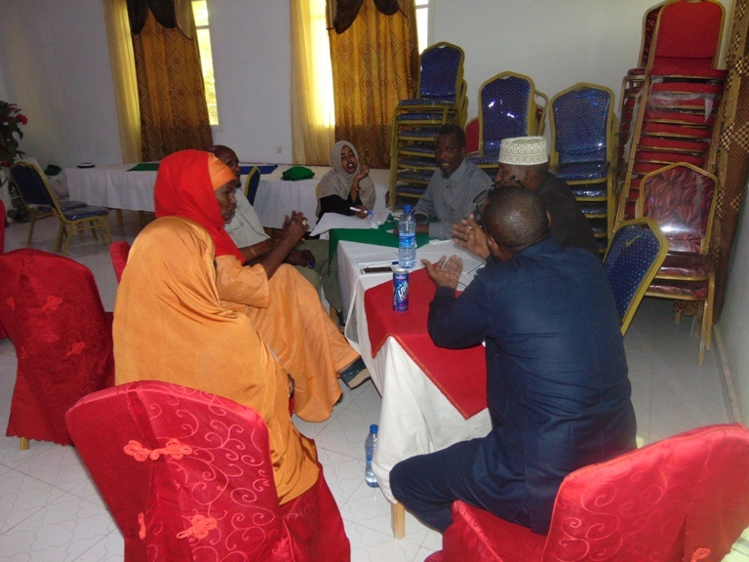
Group meeting discussing
One of the group leaders presenting their findings
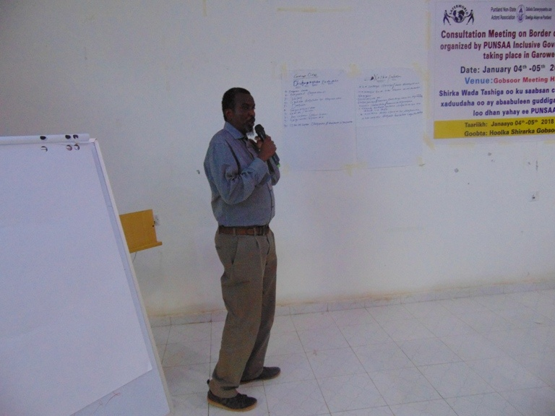
Group presentations
Groups are discussing for possible solutions on districts border demarcations

Topic 3: Comprehension of the existing problems and recommend solutions to address those problems through group discussions
In the second session, there were wide discussion on the existing problems and recommended solutions to address those problems with individual questions, group discussions and different ideas on the context itself. However, the following were the main inputs:
Boundaries demarcation can be done but mobilization of the communities has to be set, meant to know the usefulness of demarcation added the strong value is tribal issue in which early discussion will not be able to achieve the realistic goals of the state

Day 2
In day 2, a recap was made by participants for the first day topics through questions. The participants presented their understanding regarding to the topics that was covered yesterday
Topic1: The possible solutions for Puntland Districts/Regions border disputes
In the first session of day 2, there was a very strong discussion among participants to pick out the curious information within the topic sharing the information they have had with others and facts on the ground in Puntland based on the tribalism which would become obstacles facing on border demarcation.
Topic 2 of day 2
After long discussions, the participants were also agreed if the recommendation of this consultation meeting has been implemented the Upcoming of Puntland 2019 elections will be easily managed. Finally the meeting was officially closed the Deputy Minister of Puntland Ministry of Interior (MoI) and Statement on Border Demarcation was produced by the meeting participants.
Conclusion
The meeting went well and ended with success. The chairperson of the IG TWG (Ms Faduma Dirie) and PUNSAA Executive Director thanked to the participants for their excellent participation in this consultation meeting. All the participants were satisfied the outcome of the meeting.
Jointly prepared by:
- Faduma Dirie Nor - IG TWG Chairperson
- Mohamed Jama Ali - IG TWG Deputy Chair
- Wa'ays Aidarus Gure - IG TWG Member
- Ahmed Muse Mohamed - PUNSAA Project Officer

